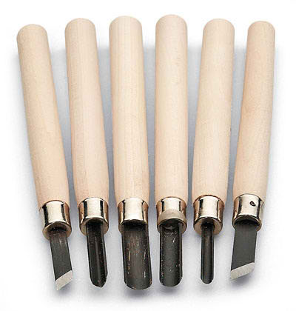
WOODBLOCK PRINTING

Woodblock or woodcut printing is a transfer printing technique that involves cutting into the wood so that the remaining surface can be inked and then printed. If the image is solely black and white, it is most common that you are cutting away the areas that you want to be white.
Colour printing can be done by first cutting the areas of white and then sequentially cutting the lightest colour until you finally print the darkest colour or black.
The cutting tools vary in order to create a range of interesting marks.
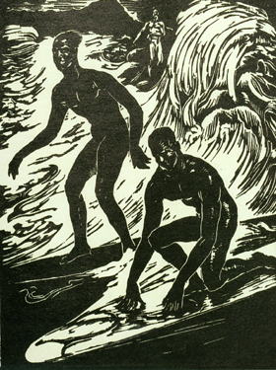

Ambrose_Patterson's_wood_block_print_'Surfriders, _Honolulu', _c.1915

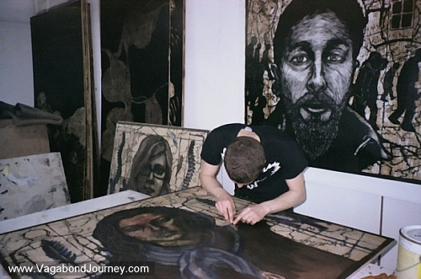
http://www.vagabondjourney.com/travelogue/vagabond-woodblock-print-by-justin-catania/
The wooden surface is rolled with printing ink and is then placed in a printing press against the paper that will take the image.
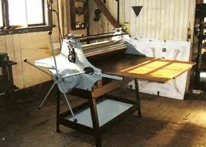
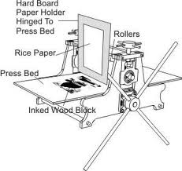
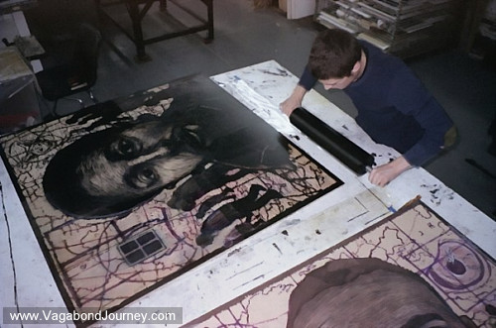
The great thing about printing is, as long as the wooden board is still in good order, you can print as many copies as you like.
The History of woodblock printing
Woodblock printing is a technique for printing text, images or patterns used widely throughout East Asia and originating in China in antiquity as a method of printing on textiles and later paper.

As a method of printing on cloth, the earliest surviving examples from China date to before 220.

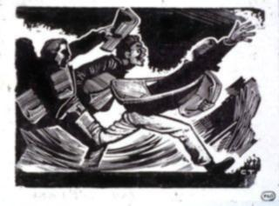
Ukiyo-e is the best known type of Japanese woodblock art print. Most European uses of the technique on paper are covered by the art term woodcut, except for the block-books produced mainly in the 15th century.

http://en.wikipedia.org/wiki/Woodblock_printing

Task 1,
FIND OUT- Using a range of sources, write a summary of the history of woodblock printing. Include images and drawings. Reference every image that you paste into your RWB.

Task 2,
GOING FURTHER- Research artists who have produced work using a woodblock printing method. It could be interesting to look at traditional and contemporary artist in order to make comparisons. How has the influence of technology changed printmaking processes over time?

Task 3,
Using the research elements of History, Culture and Society, plan four to six concept sketches using black and white media. Reflect on which media best presents your intended outcome.
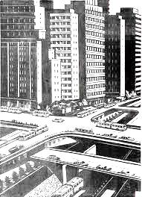
Draw your final image in black media that best suits your narrative.

Task 4,
Draw your image onto the woodblock in black marker pen.

Task 5,
Cut out the areas that you want to print white, leaving black lines and details. Use the cutting tools to create a wide range of marks. Check your image by rubbing onto thin paper with crayon. These checks can be added into your IWB for reflection purposes.

Task 6,
When you are creating your print, document the process of inking and printing by taking photos, making notes and by drawing small diagrams.

Tip if you are using text, you need to reverse the letters.
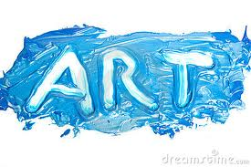
Some artists you may wish to consider………….

Swoon 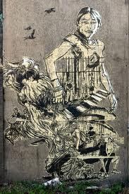 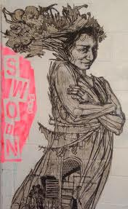 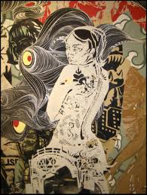 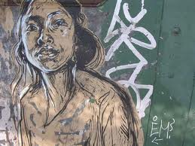

Nigel Brown 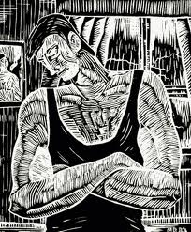 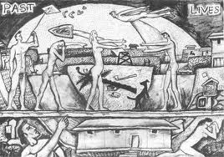

Hokusai 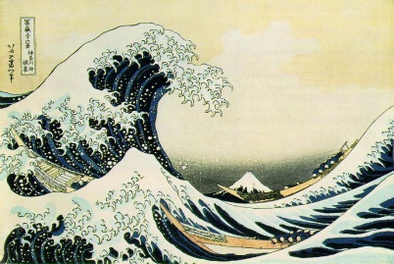 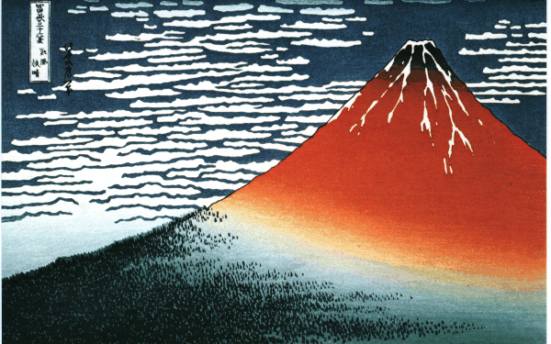

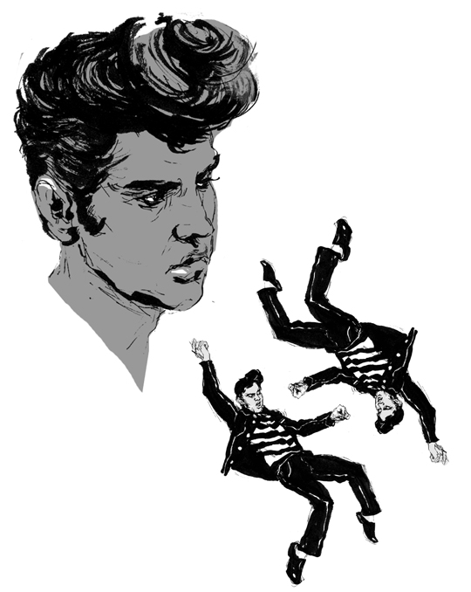
Beryl Chung
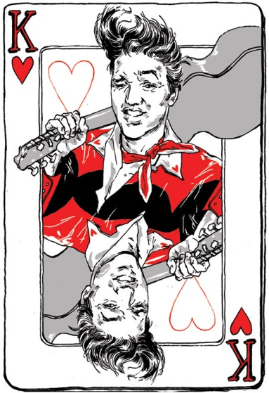

Phil Guy

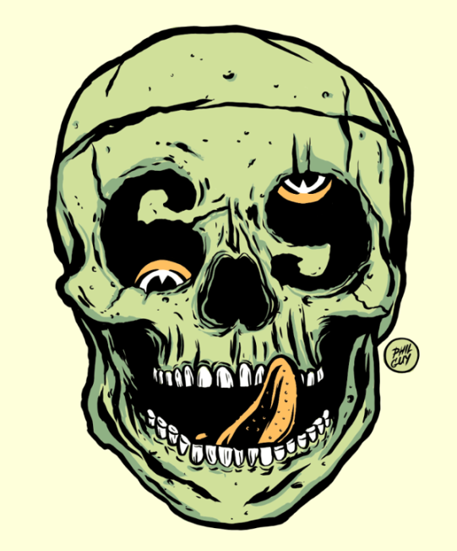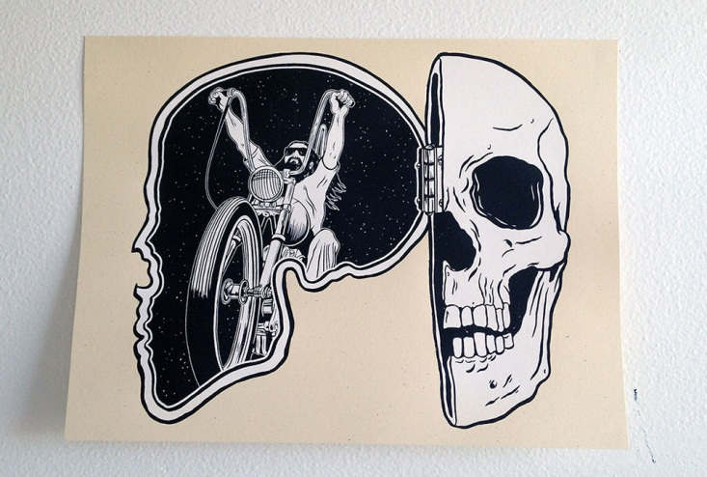

Max Beckmann

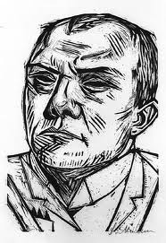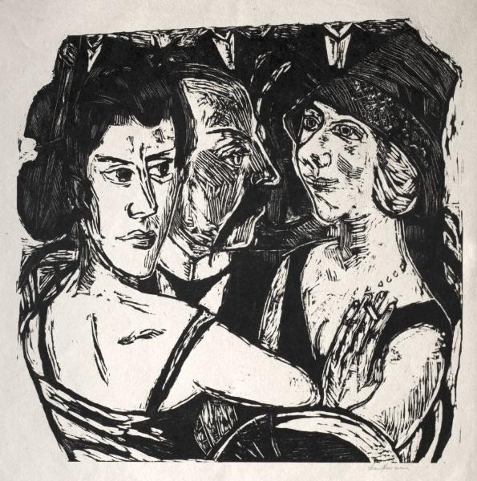

Please consider the influence of non-print based artists also. Try to extend the influence of artists that you have been informed or inspired by.

Due April 3rd, period 2.

Present your final art work along with a minimum of ten pages in your workbook.
Display in the corner studio and prepare for a group critique.

